**Recent Advances of a Wearable Sensing Glove and Sensory Feedback Device for Rehabilitation and Improved Control of Impaired Upper Limbs and Prostheses**

Carl Demoldera, Alicia Molinaa, Frank Hammondd,e, and Woon-Hong Yeoa,b,c,*

a George W. Woodruff School of Mechanical Engineering, Institute for Electronics and Nanotechnology, Georgia Institute of Technology, Atlanta, GA 30332, USA.

b Wallace H. Coulter Department of Biomedical Engineering, Parker H. Petit Institute for Bioengineering and Biosciences, Georgia Institute of Technology, Atlanta, GA 30332, USA.

c Center for Human-Centric Interfaces and Engineering, Neural Engineering Center, Institute for Materials, Institute for Robotics and Intelligent Machines, Georgia Institute of Technology, Atlanta, GA 30332, USA.

d Institute for Robotics and Intelligent Machines, Georgia Institute of Technology, Atlanta, GA 30332, USA.

e Adaptive Robotic Manipulation Lab, Georgia Institute of Technology, Atlanta, GA 30332, USA.

* Corresponding author: whyeo@gatech.edu (W.-H.Y.)

**Abstract**

Recent technological advancements in soft actuators, flexible electronics, and data acquisition systems have enabled the creation of a portable, low cost, and unobtrusive wearable sensing glove that is used in conjunction with a sensory feedback device. The combination of a wearable sensing glove and a sensory feedback device advances the status quo in healthcare, prosthetics, robotics, and virtual reality applications. This application has emerged as a promising paradigm to enhance the care provided to patients with neurological and musculoskeletal conditions. This paper includes the most up-to-date materials, sensors, actuators, and system-packaging technologies used to develop a wearable sensing glove and sensory feedback device. Details of the mechanical, electrical, system architecture, and material properties are discussed regarding their application in healthcare, prosthetics, and rehabilitation. Additionally, the limitations of the current materials and technologies are discussed, as well as the key challenges and the future direction of how a wearable sensing glove will be used in conjunction with a sensory transfer device. Overall, this paper presents an all-inclusive review of the technologies used to develop a wearable sensing glove and a sensory feedback device.

**Keyboards:** Wearable sensor glove, Sensory transfer device, Sensor glove, Data glove, Feedback device

**1. Introduction**

During the last half century, technology has rapidly advanced allowing us to begin to integrate technology into wearable devices to measure, enhance, and improve the interaction between our body and the environment. Out of all our body parts, our hands are one of the most important tools we use to interact with and manipulate our environment. For that reason, a wearable sensing glove is used measure the interaction between one’s hands and the environment. A wearable sensing glove is a wearable device worn on the hand that includes sensors to measure the interaction between our hands and the surrounding environment. Many sensors can be put on a wearable sensing glove to measure some of the following parameters: motion, position, temperature, pressure, contact, and relative finger location. Numerous applications have arisen over the past thirty years that require the use of a wearable sensing glove to achieve their goal.

However, there has been a growing need for a device to be used in conjunction with a wearable sensing glove; a device to transfer or replicate the sensory information from the wearable sensing glove to another part of the body. The need for this device combination arises from users who have a form of sensory impairment. Sensory impairment is a symptom of a variety of neurological conditions such as spinal cord injuries (SCI), cerebral palsy, peripheral neuropathy, sclerosis, and diabetes. Additionally, amputee patients face a similar issue with their prosthetics, which are currently unable to sense or feel. The lack of tactile, proprioceptive, and temperature feedback from a limb (whether human or artificial) often leads to a feeling of disembodiment over the limb, resulting in the reduced use of the limb or rejection of the prosthetic all together [Design and evaluation of a sensory...][7].

A sensory feedback device provides another form of feedback to compliment the visual feedback for users with a form of sensory impairment. Currently, patients with a form of sensory impairment rely solely on vision as a feedback mode to determine the state of their limbs, which can be very cumbersome to them [4]. The need for a device that can communicate the sensory and physical states of a sensing-less limb is evident.

Overall, we provide an extensive survey of all the technologies used in wearable sensing gloves and sensory feedback devices to provide readers with a broad overview on how these technologies can be used in tandem. Additionally, we hope to inform the non-specialist reader who is interested in using a wearable sensing glove and sensory feedback device for their application. The motivation for writing this paper is that the important information on wearable sensing gloves and sensory feedback devices are scattered across numerous engineering, commercial, and scientific literature. The main objective of this paper is to identify the advantages and drawbacks of each technology and identify potential room for improvements.

**2. Wearable sensor glove**

This portion of the paper focuses on the recent advancements in wearable sensing glove technology as well the applications that they are used for. There are a few literature reviews conducted on wearable sensing gloves. A literature survey conducted by Dipietro in 2008 provides a broad overview of wearable sensing gloves, their characteristics, and their application (Dipietro et al. 2008). As technology is being integrated into wearable sensor gloves more often nowadays, a more focused literature review is required, as a wearable sensing glove can include a sensor to measure anything from detecting fentanyl (Barfidokht et al. 2019) to detecting diverse biomarkers (Bariya et al. 2020). If the reader is looking for an application-specific survey for wearable sensing gloves, there are few resources to guide readers. A literature survey conducted by Pasquale in 2018 focuses on how wearable sensing gloves can be used for medical applications (Pasquale 2018). A literature review conducted by Rashid and Hasan in 2019 reviews how wearable technologies are used for hand joint monitoring for rehabilitation (Rashid and Hasan 2019). A literature review conducted by Ahmed in 2018 reviews how wearable sensing gloves are used for sign language recognition between 2007 and 2017 (Ahmed et al. 2018). A literature review conducted by Chen in 2020 reviews how wearable sensing gloves are used for hand pose estimation (Chen et al. 2020). Although there are numerous sensors this paper could review, this paper is focused on reviewing wearable sensing gloves that use pressure, temperature, and strain sensors. These sensors measure the main interactions patients with sensory impairment disorders need to have transferred to another part of their body. Overall, a wearable sensor glove is the optimal wearable device for this application as it is a noninvasive wearable, it increases the accuracy and repeatability of measurements, and it improves the complexity of the measurements taken to simultaneous measure different sensors (Pasquale 2018).

The focused breadth of this section will concentrate the discussion and enable a more in-depth review of these technologies. This paper will survey academic papers, commercial products, and Do-It-Yourself (DIY) projects to highlight the manufacturing method, application, and characteristics of the sensors used. The advantages and drawbacks of the technologies used are highlighted to identify potential room for improvements in this research domain. After reviewing the sensors used in existing applications, the future direction of wearable sensing gloves will be discussed to guide readers in their research development.

**2.1. Application of wearable sensing gloves**

Wearable sensing glovesare used in a multitude of applications, and the number of applications continues to grow as the technology used to make them has rapidly improved. In 2008, Dipietro created a summary table to detail the many applications for wearable sensing gloves and the rationale to use a wearable sensing glove, alternative device instead of a wearable sensing glove, and the purpose to use the wearable sensing glove. Dipietro divided the applications into two main categories: classical and recent applications. In the classical category, Dipietro choose to select the following applications: design and manufacturing, information visualization, robotics, arts and entertainment, and sign language recognition. Dipietro choose to categorize healthcare and computers in the recent category (Dipietro et al. 2008). **Table 2** is formed by building from this previous work and expanding on it by including more applications due to recent technological advances. The “classical” application category has been redefined to the following: design & manufacturing, information visualization, arts & entertainment, sign language recognition, and computer. The “recent” application category had been modified to include the following: virtual reality, health care diagnostics, prosthetics, robotics, and artificial intelligence.

Researchers in the field of virtual reality are using wearable sensing gloves to allow users to interact with their computer-generated environment and perform digital movements in a more natural way. In the field of health care, they allow researchers to take measurements easily and directly between the user’s hand and the surrounding environment. In the field of prosthetics, they allow the user to improve the control and adoption of the prosthetic by providing a form of feedback to the user. In the field of robotics, they provide a way to measure the interaction between the robotic hand and the surrounding environment. This will provide a closed feedback loop for robotic systems. In the field of artificial intelligence, they provide users with the ability to perform object detection and gesture recognition and model human interactions. In the next few sections, the application that the commercially available, DIY, or academic version of the wearable sensing glove is designed to target is mentioned.

**2.2. Commercially available wearable sensor gloves**

While numerous glove designs have been proposed over the past 30 years, only a few products have become commercially available and viable. A literature review conducted in 2008, provides a thorough description of wearable sensors gloves from the 1970s to 2008 (Dipietro et al. 2008). Today, there are commercially available wearable sensing gloves that integrate a myriad of different sensors. A few notable examples of wearable sensing gloves that use different sensors that will not be discussed in this literature review are the Noitom Hi5 VR Glove (Noitom 2021) that uses an internal measurement unit (IMU), the Workaround ProGlove (Workaround 2021) that uses an industrial bar-code reader, and the SenseGlove that provides force-feedback for VR training (SenseGlove 2021). Rather, this section will focus on commercially available products that implement either temperature, pressure, or strain sensors into a wearable sensing glove.

The commercial wearable sensing gloves that integrate temperature sensors are represented below. The SensPro 8108 by Holik International use an infrared thermometer and contact temperature sensors located in a protective glove. An image is shown in Fig. 3K and this glove is primary used to warn firefighters of the temperature of certain objects before they touch them (SensPro 2021).

The commercial wearable sensing gloves that integrate pressure sensors are represented below. The Pliance Glove by Novel GmbH uses 256 capacitance pressure sensors and can record at a measurement frequency of 20,000 samples per second and an image is shown in **Fig. 3A**. This glove is primarily used to model the human interaction between users and manufacturing and production tools. Additionally, it can be used for assessing manipulations and hand rehabilitation during physical therapy practice (Novel 2021). The Finger TPS by Medical Tactile Inc includes a capacitance pressure sensor on the fingertip of the glove and an image is shown in **Fig. 3I**. This glove is primarily used to optimize a product’s ergonomics by quantifying the user interaction’s with the product (PPS 2021a). The TactileGlove, also by Medical Tactile Inc, includes capacitance pressure sensors throughout the entire glove – fingers to palm. An image is shown in **Fig. 3J** and it is primary used to map human movements and quantify the user’s hand interactions to optimize the ergonomics of a product (PPS 2021b). The Peregrine Glove ST by Peregrine has 17 touch point contact sensors (5 touch sensors per long finger and 2 touch sensors on the small finger). An image of the glove is shown in **Fig. 3M** and it primarily used for computer interaction control and VR applications (Peregrine 2021). The Glove Pressure Mapping System (GPMS) by Vista Medical, Ltd is a wearable sensor glove with various pressure sensors mounted on the hand in different locations. An image of the glove is shown in Fig. 3P and it is primarily used for to quantify human movements and quantify the user’s hand interactions to optimize the ergonomics of a product (Vista Medical).

The commercial wearable sensing gloves that integrate strain sensors are represented below.

The VMG 8 by VRealities LLC uses 1 embedded strain sensor per finger to accurately measure the finger movements and an image is shown in **Fig. 3B**. This glove is primarily used for virtual reality applications (Virtual Realities 2018). The MoCap Pro by StretchSense uses multi-segmented splay sensors to detect the bending of each knuckle as well as the lateral spread. An image is shown in **Fig. 3C**. This glove is primarily used for VR/AR applications and motion capture (StretchSense 2021). The Stroke-Rehab Glove by Anthrotronix uses strain sensors to detect finger bending and an image is shown in **Fig. 3D**. This glove is primarily used for healthcare applications as this glove helps patients regain the fine motor control that they may have lost due to brain damage and muscle weakness caused by a stroke (Anthrotronix 2021). The Flexpoint USB Glove Kit by Flexpoint Sensor Systems includes a dual segment bend sensor for each finger and an image is shown in **Fig. 3E**. This glove can be used for a variety of medical applications from determining a patient’s level of monitor skill, post-surgery evaluation, and assisting the disabled (Flexpoint 2021). The CaptoGlove by CaptoGlove Inc includes a bend sensor for each finger and an image is show in **Fig. 3F.** This glove is primarily used for pc gaming and for virtual realities applications (CaptoGlove 2020). The Smart Glove for Home by Neofect USA includes a bend sensor for each finger and an image is shown in **Fig. 3G**. This glove is primarily used as a medical device to quantify even small movements of the upper extremity to better promote repetition, optimal for brain retraining to improve motor function (Neofect 2021). The BeBop Forte Data Glove by BeBop Sensors includes a bend sensor in each finger and has haptic feedback in the glove. An image is shown in **Fig. 3H**. This glove is primarily used for VR and AR applications (BeBop 2021). The Mimu Gloves by Mi Mu Gloves Limited includes a bend sensor in each finger and an image of the glove is shown in **Fig. 3L**. This glove is used as a wearable musical instrument for expressive creation, composition, and performance (MimuGloves 2021). The Manus Prime II Haptic by Manus VR includes a bend sensor in each finger and provides haptic feedback to the user as well. An image is shown in **Fig. 3N** and it is mainly used for motion capture, virtual reality and augmented reality applications (Manus-VR 2021). The 5DT Data Glove 5 Ultra includes a bend sensor in each finger and an image of the glove is shown in Fig. 3O (5DT 2021).

These commercially available wearable sensing gloves provide the reader with an understanding of what features and sensors have been implemented at a production level. Additionally, it should help guide researchers to understand what products they could purchase to integrate with their research. Also, it should help to understand what features are important to implement into a sensor glove. It can be a way to gauge demand and understand where the need for a product is.

**2.3. Do-It-Yourself wearable sensor gloves**

Do-It-Yourself (DIY) versions of wearable sensor gloves provides an interesting perspective for readers. The manufacturing methods engineers and artist use to make these wearable sensor gloves differs dramatically from the commercial and academic versions. With hand tools and minimal equipment, they are still able to build a wearable sensor glove that accomplishes their proposed task.

Zack Freedman was able to build the Parametric Data Glove by 3D printing ring-like fixtures to secure flex sensors on the back of the finger. This design exposes the fingers and the palm, and this low friction design maximizes the user’s maneuverability as one can see in **Fig. 4A** (Freedman 2016). User vu2aeo on Instructables built a low-cost wearable sensing glove using off-the-shelf flex sensors on the back of the hand. An Arduino then read the flex sensors and controlled a robotic hand to mimic the movements of the user’s hand as shown in **Fig. 4B** (vu2aeo 2021). Will Donaldson built a similar device as User vu2aeo as shown in **Fig. 4G**. Donaldson used velostat as a piezoresistive material to build the strain sensors to measure how much each finger bends. He then used an Arduino Lilypad to read the strain sensors and manipulate a robotic hand to mimic his hand movements (Donaldson 2021). Rachel Freire built a low-cost wearable sensing glove using flex sensors made from resistive fabric as shown in **Fig. 4H**. These fabric sensors were read by a microcontroller on the back of the hand to control LEDs (Freire 2021a). Rachel Freire decided to expand on this technology by integrating a Vive Tracker into her wearable sensor gloves. By integrating textile based strain sensors on the back of the hand, she was able to build wearable sensing gloves that can integrate with virtual reality environments as shown in **Fig. 4E** (Freire 2021b).

Brian Benchoff took a creative approach by building a wearable sensing glove that doubles as a musical instrument. Using a pressure sensor and flex sensors on the fingers, he was able to mimic the behavior of a musical instrument. By blowing in a tube that is connected to a pressure sensor that is mounted to the thumb, he can increase or decrease the amplitude of a musical note. To change the musical note, he moves his fingers towards his palm (Benchoff 2011).

User ‘Plusea’ on Instructables built a low-cost wearable sensing glove with pressure sensors on each fingertip as shown in **Fig. 3F**. The pressure sensors were made using piezoresistive Eeonyx fabric and stretchable conductive fabric. The goal of this wearable sensing glove was to build a device to help piano teachers teach children to visualize the difference between soft and hard touches (Plusea 2021). User ‘DanielE58’ on Instructables built a low-cost wearable sensing glove with off-the-shelf strain sensors on each fingertip as shown in **Fig. 3I**. User ‘DanielE58’ designed the wearable sensor glove to be used as a gesture-based input device to control one’s computer (DanielE58 2021).

User ‘emcnany’ on Instructables built a low-cost wearable sensing glove with flex sensors on the back of each finger and conductive fabric to detect fingertip touches as shown in **Fig. 3D**. This wearable sensing glove is designed to be used as a general I/O device and it includes haptic feedback in the palm of the hand (Emcnany 2021). User ‘Shja7942’ on Instructables built a low-cost wearable sensing glove with flex sensors on the back of each finger as shown in **Fig. 3C** (Shja7942 2021). This glove is designed to assist individuals who have difficulty communicating using speech. The glove recognizes hand gestures and American signed language letters and converts it to speech using a speaker (Shja7942 2021).

Overall, the DIY versions of wearable sensing gloves provides the reader with information on how artists, designers, and engineers are applying this technology to their creative applications. The technology they use is not cutting edge, however, it demonstrates how normal people are using this technology to solve the problems they are facing. Hopefully, readers take away the sentiment that there are applications for wearable sensor gloves and many unsolved problems.

**2.4. Academic advancements in sensor technology for sensor gloves**

Researchers at universities have been developing new versions of sensors for years, however they have recently started putting those sensors on gloves to create wearable sensing gloves. The sensors put on wearable sensing gloves integrate different techniques of nano manufacturing techniques. Additionally, the more recent advances in these sensors have start to use different combination of nano materials. These sensors have better sensitivity and better mechanical properties than commercially available products. **Fig. 2** depicts a Venn-diagram where each section of the pie is used to build the center image which is an artificial skin that can measure pressure, temperature, and strain. Each individual image used to conduct the Venn diagram is explained in the sections below. The ultimate wearable sensing glove is a durable, thin membrane that can be worn on the hand that combines all three sensor nodes into one form factor. Through the process of conducting this literature review, it is evident that there is a need for an artificial skin that is a very thin membrane that can be used as a wearable sensor glove. **Fig. 2J** is an example of artificial skin with pressure, strain, and temperature sensors made from single crystalline silicon nanoribbon (Kim et al. 2014). The advances in artificial skin are documents in a literature review conducted by Chortos in 2016 (Chortos et al. 2016). In this literature review, the author details the new materials and fabrication strategies that are being developed to make multifunctional skintronics (skin-like electronics). The combination of pressure, temperature, and strain sensors in a single membrane provides the ultimate wearable sensing glove. However, the current limitation of these sensors is the sense complex stimuli such as surface textures and object shape. A large number of receptors are necessary to provide a more natural feel for prosthetics (Chortos et al. 2016). Another literature review was conducted in 2020 that provides another in depth review of skin-inspired multifunctionality at the prosthetic level using flexible electronics and mechanical compliant biometric sensing platforms. Additionally, this review going into depth about implantable electrodes to connect with exposed neurons. This a great supplementary resource to see where the future of artificial skin can be used to interact with prosthetic devices (Li et al. 2020a). The combines all three major sensing nodes into one glove system.

Another literature review was conduct in 2017 to present the historical development of hand gesture recognition using glove-based control interfaces for computer control (Premaratne 2017).

Although there is only one example of a wearable sensing glove combining all three sensor nodes into one form factor, most of the academic references explore the advancements in sensor technology in one sensor node. **Table 1** provides a summary of the sensors used on wearable sensing gloves. The material, mechanical, and electrical properties of the sensor used are documented and the application that the wearable sensing glove is used in is documented. Each reference is explained in detail in their corresponding sensor section below.

**2.4.1. Strain sensor**

A strain sensor was composed from fragmentized graphene foam. This strain sensor is manufactured from a composite of fragmentized graphene foam (FGF) and polydimethylsiloxane (PDMS). The graphene foam is disintegrated into 200-300 um sized fragments. It shows a high sensitivity with a gauge factor of 15 to 29, high stretchability over 70%, and high durability over 10,000 stretching-releasing cycles (Jeong et al. 2015).

A highly flexible, stretchable, and sensitive strain sensor based on the nanocomposite of silver nanowire (AgNW) network and PDMS elastomer in the form of a sandwich structure. This sensor has a gauge factor ranging from 2 to 14 and a stretchability up to 70%. This strain sensor was integrated onto a glove for motion detection of fingers to control an avatar in a virtual environment (Jeong et al. 2015).

A glove capable of wirelessly translating the American Sign Language (ASL) into text displayable on a computer of smartphone. A strain sensor is placed on the knucles of each finger (two strain sensors per finger, 1 strain sensor for the thumb). These strain sensors are made from from carbon paint on PDMS material with a PU encasement. Copper tape is attached to the PDMS and conductive thread is used to attach the strain sensor to the circuit elements. The entire system was constructed with less than $100 and did not require access to a cleanroom for completion (Premaratne 2017).

**2.4.2. Pressure sensor**

A robotic hand is equipped with artificial ridged skin over top of a resistance pressure sensor was used to detect slip. The geometry of the silicone ridges that is placed on top of pressure sensor allows one to detect slippage and to quantify the slippage speed. This information can be relayed back to the user as a form of tactile feedback information (Damian et al. 2010).

Pressure is detected using fluidic pressure changes in fibrous flexible tubes. These flexible tubes are sewn throughout the gloves and a tube is used per finger and one is used for the palm. Through the use of pressure transducers, the pressure change is measured and used for real-time hand pose reconstruction, environment sensing, and task classification (Hughes et al. 2020).

Another example of artificial skin integrating strain and pressure sensors is conducted by sputterin an Ag thin film on a PET frame to form Ag serpentine-shaped electrode frame. This sandwich structure consists of Ag/PET/PDMS films encapsulated Ecoflex material. The pressure sensor compresses the PDMS material which causes a change in capacitance. It has a pressure sensitivity value of 1.45 MPa-1 and it has the ability to stretch up to 70% (Zhao et al. 2015).

**2.4.3. Temperature sensor**

A fully soft, wearable glove uses an OTS temperature sensor, LM35 temperature sensor by Texas Instruments, which is used for environment sensing. The LM35 temperature sensor has a small package size (4.30 mm x 4.30 mm), temperature range from -55°C to 150°C, and an analog output with a 10 mV/°C scale factor (Hughes et al. 2020).

The e-glove system was built off of a commercial stretchable nitrile glove by applying epoxy on the surface to provide adhesive support. An conductive AgNW ink was screen-printed onto the surface of the glove to act as the interconnects between the sensors and the testing elements. The temperature sensors are made of Au (100 nm thick_ and filamentary serpentine interconenctors (Au, 300 nm thick) ADD MORE TO THIS (Kim et al. 2019).

**2.5. Limitations and challenges**

Although these wearable sensor gloves have improved the status quo, they are lacking in many different areas. Many examples presented in this paper are bulky and cumbersome to use. They require a thick membrane (fabric, plastic, or leather) to attach these sensors to a user’s hand. Additionally, there is a lot of room to improve the data acquisition system. Most examples present a small sensor with a large data acquisition system. This data acquisition system is occasionally wired requiring a cable to provide power to the wearable sensing glove. This presents a poor user interaction that could use some improvement. With the recent advancements in Bluetooth, the longer range and higher data transfer rates enable sensor gloves to use a small Bluetooth transmission module to transmit the data collected from the various sensors on the sensor glove. The major drawback moving forward for wearable sensing gloves is the size and weight of the battery. Advancements in nano particle manufacturing enable smaller sensors to be manufactured, flexible circuit boards to be thinner and flexible. However, until the energy density of batteries is dramatically improved, the battery will be the largest inhibitor to seamless user interaction.

Finger sweatiness during a prolonged performance was also success-fully eliminated by using a breathable fabric.

Various improvements have been made to the gloves since their introduction to the market, and they are advertised to fit to human hands well because they are stretchable and lightweight. However, these gloves tend to feel hard and tight because of the bending sensors and hard glove fabrics, and users’ hands tend to become sweaty after long-term use; further improvements are highly desirable.

**3. Sensory feedback device**

People with sensory impaired or artificial limbs are unable to determine the current state of their limbs at any given time and rely on vision and memory to manipulate their limbs. Dexterous limb manipulation relies on a closed loop control comprised of motor output and incoming sensory feedback [6]. For instance, when ordered to grasp an object, the brain outputs a motor signal to the hand which uses memory to anticipate the forces and position needed to complete the given task. Once the hand has grasped the object, cutaneous sensation feedback is sent back to the brain and forces and position are adjusted as needed [10]. While a healthy limb would be able to achieve this naturally, a sense-less or artificial limb lacks the ability to adjust to its environment as needed. If the object being grasped requires an unexpected force, a hand unable to sense would likely drop the object as it wouldn’t be able to adapt accordingly. The lack of sensory feedback can also be dangerous as the person is not able to sense when it feels pain, whether it is from encountering a sharp object or a burning surface.

Efforts to tackle this issue include the development of wearable sensory feedback devices which display sensory data cutaneously on a part of the body that is able to sense. The feasibility of such a device has been widely researched throughout the years. Furthermore, these sensory feedback devices have been proven to decrease the cognitive effort required to manipulating an artificial limb, when compared to vision as the sole feedback [18]. Different methods and devices are discussed in further detail in the following sections, focusing on the different ways in which stimulus is created.

**3.1. Feedback modes**

Determining an appropriate feedback method is crucial to the success of the feedback device. Sensory feedback modes are divided into 3 categories, listed from most artificial to most authentic: substitution, modality matched, and somatotopically matched feedback. Substitution feedback doesn’t match the modality of stimulus. This category includes vibrational and electro tactile feedback. Modality matched feedback is congruent to external stimulus. This category includes mechanotactile feedback, or pressure. Somatotopically matched feedback is perceived as if it were on the location where the stimulus is applied. This category involves invasive procedures such as peripheral nerve stimulation and targeted reinnervation. [6]. Naturally, modality matched feedback is preferred as it eases the cognitive burden on the user by being more intuitive [14]. Therefore, a feedback device should be designed to match stimulus modality when possible [7]. *Add transition

**3.1.1. Electro cutaneous**

Electric stimulation can be an effective and size efficient way to display sensory feedback. Scott et al. Used electric square waves with a frequency of 3 kHz and a rate between 0-60 pulses/sec to display pinch forces measured by strain gauges of an artificial hand. The signal’s rate was mapped to a corresponding force ranging from 0 to 100 N. This method proved to be useful specially when carrying light objects which would otherwise be dropped in the absence of feedback. [2]. Damian et al. Used electrotactile vibrations on the lumbar area to represent the slipping speed of a distant object. The ability of subjects to prevent the object from slipping was studied with visual feedback only, blind feedback that was not proportional to the rate of slip, and blind feedback congruent with slip speed. Slip speed feedback was the most successful for preventing object drop. The study also showed that as the study progressed, there was no learning; meaning that the subject’s ability to control the slipping object completely depended on the feedback display. [19]. This is significant as it reiterates the need of such a device and the importance of designing a device that is wearable and ergonomic.

**3.1.2. Vibrotactile**

Vibrotactile feedback is undoubtedly the most used feedback method due to its affordability and small form factor [20]. Multiple research efforts have investigated vibrotactile displays for manipulation of artificial limbs, control of impaired extremities, and motor learning.

Jiang et al. Developed a low-cost haptic display for multiple sclerosis (MS) patients who often experience reduced sensation causing them to overcompensate and use larger than needed forces when lifting objects. The goal was for subjects to apply the same amount of force on each finger to reduce the overall force being used during lifting. Feedback was delivered using small vibrating motors and evaluated using two methods: event cue (ECF) and amplitude-based feedback (ABF). ECF provided vibration only when the measured force went below a given threshold. ABF provided constant feedback proportional to the magnitude of the force applied. The study concluded that feedback improved the subject’s ability to control the forces on their fingers, and the method preferred depended on the level of impairment of the subject. Those most impaired found ABF most useful while those with lingering sensation found ABF overwhelming and unnecessary. [11]. Walker et al. Used vibration to prevent slip of objects in prostheses users. The study found that visual feedback is the extremely important and their main feedback source, but when not available, added feedback is essential to prevent slip. [13].

Vibrotactile feedback is also widely used for corrective feedback. Redd et al. used a smartphone application to provide vibratory feedback to correct gait issues [5]. While Lieberman et al. developed a sleeved vest which provided vibrotactile feedback for motor learning. The suit could be used for improvement of gait issues and even learning how to dance. The suit provided vibrations proportional to the error of the desired movement. The vibrotactile suit made users more aware of their errors and consequently improved performance. The study also found that skin is most sensitive to frequencies around 20 Hz. [12].

*mention studies comparing vibration to other modalities and how although is it greatly used because it is easy and affordable it may not be the optimal feedback mode since it is not modality matched

**3.1.3. Mechanotactile**

Amongst the discussed feedback modalities, mechanotactile feedback is the only that is modality matched. It’s effectiveness at sensory substitution and its superiority over other modalities has been established by various studies.

**3.1.3. Other novel approaches**

Sdsd

**3.2. Limitations and challenges**

Sdsfs

**4. Conclusions and future perspectives**

In this paper, we presented a survey of wearable sensor gloves, as well as a survey of sensory transfer devices. We narrowed the scope of the wearable sensor gloves to focus on three main categories: temperature, strain, and pressure. We presented commercially available, DIY, and academic versions of sensor gloves that integrate these sensors into a glove form factor. We critically analyzed the technology used to measure these sensor categories, and we mentioned their advantages and drawbacks for each novel technique used. Although this literature review only focused on the sensors used in wearable sensor gloves, there are many different methods to manufacture a temperature, strain, and pressure sensor that have not been integrated onto a wearable sensor glove yet. There is room for innovation and improvement in wearable glove technology, as stretchable, flexible sensors can be integrated into wearable sensor gloves. The improved mechanical properties of these sensors can reduce the thickness of the wearable sensor glove, increase the user’s comfort, and allow the user to interact with their environment in a more natural way. Regarding the sensory transfer device, various methods are presented to translate sensory information in the hand to other parts of the body. We presented background information regarding electro cutaneous, vibrotactile, and mechanotactile feedback methods. These feedback mechanisms have had limited success so far and improvements can be made to reduce the size of these mechanisms and increase the cognitive response to distinguish between various stimuli. Overall, wearable sensor gloves and sensory transfer feedback devices will have a greatly improve the status quo in prosthetics, rehabilitation devices, and virtual reality applications.

**Authorship contribution statement**

**Carl Demolder:** Conceptualization, writing – original draft, review, and editing.

**Alicia Molina:** Conceptualization, writing – original draft, review, and editing.

**Frank Hammond:** Conceptualization, writing – review and editing.

**Woon-Hong Yeo:** Conceptualization, writing – review and editing.

**Conflict of interests**

We confirm that there are no known conflicts of interest associated with this publication. There has been no significant financial support for this work that could have influenced its outcome.

**Acknowledgements**

This literature review is supported by a grant provided by Scott Kozin, M.D., a clinician at the Shriners Children Hospital in Philadelphia, PA.

**References**

5DT, F.D.T., 2021. 5DT Data Glove Ultra. p. 5DT Data Glove Ultra. Fifth Dimension Technologies, <https://5dt.com/5dt-data-glove-ultra/>.

Ahmed, M.A., Zaidan, B.B., Zaidan, A.A., Salih, M.M., Lakulu, M.M.b., 2018. A Review on Systems-Based Sensory Gloves for Sign Language Recognition State of the Art between 2007 and 2017. Sensors 18(7), 2208.

Anthrotronix, 2021. Stroke-Rehab Glove. pp. Stroke-Rehab Glove. Anthrotronix, <https://www.anthrotronix.com/our-work/biomedical-assistive-devices/>.

Barfidokht, A., Mishra, R.K., Seenivasan, R., Liu, S., Hubble, L.J., Wang, J., Hall, D.A., 2019. Wearable electrochemical glove-based sensor for rapid and on-site detection of fentanyl. Sensors and Actuators B: Chemical 296, 126422.

Bariya, M., Li, L., Ghattamaneni, R., Ahn, C.H., Nyein, H.Y.Y., Tai, L.-C., Javey, A., 2020. Glove-based sensors for multimodal monitoring of natural sweat. Science Advances 6(35), eabb8308.

BeBop, 2021. BeBop Forte Data Gloves. p. BeBop ARVR Data Glove. Bebop Sensors, <https://bebopsensors.com/arvr/>.

Benchoff, B., 2011. Emulating a Marching Band with Wearable Instruments. p. Emulating a Marching Band with Wearable Instruments. Hackaday, Hackaday.com.

CaptoGlove, 2020. CaptoGlove Business-Single. p. CaptoGlove is a wireless wearable hand machie interface. CaptoGlove, <www.captoglove.com>.

Chen, S., Lou, Z., Chen, D., Jiang, K., Shen, G., 2016. Polymer-Enhanced Highly Stretchable Conductive Fiber Strain Sensor Used for Electronic Data Gloves. Advanced Materials Technologies 1(7), 1600136.

Chen, W., Yu, C., Tu, C., Lyu, Z., Tang, J., Ou, S., Fu, Y., Xue, Z., 2020. A Survey on Hand Pose Estimation with Wearable Sensors and Computer-Vision-Based Methods. Sensors 20(4), 1074.

Chortos, A., Liu, J., Bao, Z., 2016. Pursuing prosthetic electronic skin. Nature Materials 15(9), 937-950.

Damian, D.D., Martinez, H., Dermitzakis, K., Hernandez-Arieta, A., Pfeifer, R., 2010. Artificial ridged skin for slippage speed detection in prosthetic hand applications. 2010 IEEE/RSJ International Conference on Intelligent Robots and Systems, pp. 904-909.

DanielE58, 2021. Arduino Wearable Keyboard Glove. p. Arduino Wearable Keyboard Glove. <www.instructables.com>, Instructables Circuits.

Dipietro, L., Sabatini, A.M., Dario, P., 2008. A Survey of Glove-Based Systems and Their Applications. IEEE Transactions on Systems, Man, and Cybernetics, Part C (Applications and Reviews) 38(4), 461-482.

Donaldson, W., 2021. Flex Sensor Glove. p. Flex Sensor Glove Used To Control Robotic Arm. Instructables.com, Instructables Circuits.

Emcnany, 2021. Interactive-Gloves. p. Interactive Gloves to be used as a general I/O device. Instructables Circuits, <www.instructables.com>.

Flexpoint, 2021. Flexpoint USB Glove Kit. p. USB Glove Kit. Flexpoint Sensor Systems, <https://www.flexpoint.com/usbglovekit>.

Francés, L., Morer, P., Rodriguez, M.I., Cazón, A., 2019. Design and Development of a Low-Cost Wearable Glove to Track Forces Exerted by Workers in Car Assembly Lines. Sensors 19(2).

Freedman, Z., 2016. Project Grip - Parametric Data Glove. pp. Project Grip - Parametric Data Glove. MakerBot Thingverse, thingverse.com.

Freire, R., 2021a. DIY Glove Controller With E-Textile Sensors. pp. DIY Glove Controller With E-Textile Sensors. Instructables Circuits, <www.instructables.com>.

Freire, R., 2021b. Extextile VR Gloves for Vive Tracker. p. Extextile VR Gloves for Vive Tracker. Instructables, <https://www.instructables.com/Etextile-VR-Gloves-for-Vive-Tracker/>.

Gao, Y., Ota, H., Schaler, E.W., Chen, K., Zhao, A., Gao, W., Fahad, H.M., Leng, Y., Zheng, A., Xiong, F., Zhang, C., Tai, L.-C., Zhao, P., Fearing, R.S., Javey, A., 2017. Wearable Microfluidic Diaphragm Pressure Sensor for Health and Tactile Touch Monitoring. Advanced Materials 29(39), 1701985.

Hammond, F.L., Mengüç, Y., Wood, R.J., 2014. Toward a modular soft sensor-embedded glove for human hand motion and tactile pressure measurement. 2014 IEEE/RSJ International Conference on Intelligent Robots and Systems, pp. 4000-4007.

Hughes, J., Spielberg, A., Chounlakone, M., Chang, G., Matusik, W., Rus, D., 2020. A Simple, Inexpensive, Wearable Glove with Hybrid Resistive-Pressure Sensors for Computational Sensing, Proprioception, and Task Identification. Advanced Intelligent Systems 2(6), 2000002.

Jeong, Y.R., Park, H., Jin, S.W., Hong, S.Y., Lee, S.-S., Ha, J.S., 2015. Highly Stretchable and Sensitive Strain Sensors Using Fragmentized Graphene Foam. Advanced Functional Materials 25(27), 4228-4236.

Khan, H., Razmjou, A., Ebrahimi Warkiani, M., Kottapalli, A., Asadnia, M., 2018. Sensitive and Flexible Polymeric Strain Sensor for Accurate Human Motion Monitoring. Sensors 18(2), 418.

Kim, H.-J., Thukral, A., Yu, C., 2018. Highly Sensitive and Very Stretchable Strain Sensor Based on a Rubbery Semiconductor. ACS Applied Materials & Interfaces 10(5), 5000-5006.

Kim, J., Lee, M., Shim, H.J., Ghaffari, R., Cho, H.R., Son, D., Jung, Y.H., Soh, M., Choi, C., Jung, S., Chu, K., Jeon, D., Lee, S.-T., Kim, J.H., Choi, S.H., Hyeon, T., Kim, D.-H., 2014. Stretchable silicon nanoribbon electronics for skin prosthesis. Nature Communications 5(1), 5747.

Kim, M.K., Parasuraman, R.N., Wang, L., Park, Y., Kim, B., Lee, S.J., Lu, N., Min, B.-C., Lee, C.H., 2019. Soft-packaged sensory glove system for human-like natural interaction and control of prosthetic hands. NPG Asia Materials 11(1), 43.

Lee, J., Kim, D.W., Chun, S., Song, J.H., Yoo, E.S., Kim, J.K., Pang, C., 2020. Intrinsically Strain-Insensitive, Hyperelastic Temperature-Sensing Fiber with Compressed Micro-Wrinkles for Integrated Textronics. Advanced Materials Technologies 5(5), 2000073.

Li, P., Anwar Ali, H.P., Cheng, W., Yang, J., Tee, B.C.K., 2020a. Bioinspired Prosthetic Interfaces. Advanced Materials Technologies 5(3), 1900856.

Li, Y., Zheng, C., Liu, S., Huang, L., Fang, T., Li, J.X., Xu, F., Li, F., 2020b. Smart Glove Integrated with Tunable MWNTs/PDMS Fibers Made of a One-Step Extrusion Method for Finger Dexterity, Gesture, and Temperature Recognition. ACS Applied Materials & Interfaces 12(21), 23764-23773.

Manus-VR, 2021. Manus VR Prime II. pp. Manus-VR Prime II Haptic Manus-VR, Manus-VR.com.

MimuGloves, 2021. Mimu-Gloves. p. Mimu Gloves. Mimu Gloves, <www.mimugloves.com>.

Neofect, 2021. Smart Glove for Home. p. Smart Glove for Home using Samsung Tablet. Neofect USA, <https://shop.neofect.com/products/neofect-smart-glove>.

Noitom, I.I., 2021. Noitom Hi5. p. Hi5 VR Glove. Noitom International Inc., hi5vrglove.com.

Novel, G., 2021. Pliance Glove Sensor. p. Pliance Glove Sensor. Novel Gmbh.

Ota, H., Emaminejad, S., Gao, Y., Zhao, A., Wu, E., Challa, S., Chen, K., Fahad, H.M., Jha, A.K., Kiriya, D., Gao, W., Shiraki, H., Morioka, K., Ferguson, A.R., Healy, K.E., Davis, R.W., Javey, A., 2016. Application of 3D Printing for Smart Objects with Embedded Electronic Sensors and Systems. Advanced Materials Technologies 1(1), 1600013.

Pasquale, G., 2018. Glove-based systems for medical applications: review of recent advancements. Journal of Textile Engineering & Fashion Technology 4.

Peregrine, 2021. Peregrine Glove ST. p. Peregrine Glove ST. Peregrine Glove, <www.peregrineglove.com>.

Pizarro, F., Villavicencio, P., Yunge, D., Rodríguez, M., Hermosilla, G., Leiva, A., 2018. Easy-to-Build Textile Pressure Sensor. Sensors 18(4), 1190.

Plusea, 2021. Sensitive Fingertips. p. Sensitive Fingertips. Instructables.com, Instructables Circuits.

Polishchuk, A., Navaraj, W.T., Heidari, H., Dahiya, R., 2016. Multisensory Smart Glove for Tactile Feedback in Prosthetic Hand. Procedia Engineering 168, 1605-1608.

PPS, 2021a. Finger TPS | Finger and Hand Pressure Measurement. p. Finger TPS | Finger And Hand Pressure Measurement. Medical Tactile Inc. 2020, <https://pressureprofile.com/body-pressure-mapping/finger-tps>.

PPS, 2021b. TactileGlove - Hand Pressure Measurement. pp. TactileGlove - Hand Pressure Measurement. Medical Tactile Inc, <https://pressureprofile.com/body-pressure-mapping/tactile-glove>.

Premaratne, P., 2017. Chapter 2 Historical Development of Hand Gesture Recognition.

Qu, M., Qin, Y., Sun, Y., Xu, H., Schubert, D.W., Zheng, K., Xu, W., Nilsson, F., 2020. Biocompatible, Flexible Strain Sensor Fabricated with Polydopamine-Coated Nanocomposites of Nitrile Rubber and Carbon Black. ACS Applied Materials & Interfaces 12(37), 42140-42152.

Rashid, A., Hasan, O., 2019. Wearable technologies for hand joints monitoring for rehabilitation: A survey. Microelectronics Journal 88, 173-183.

SenseGlove, 2021. SenseGlove Nova. pp. SenseGlove Nova - The New Sense for VR Training. SenseGlove, <https://www.senseglove.com/nova/>.

SensPro, 2021. The All-Textile Protective Gloves Are Designed For Use In Extinguishing Fires. p. All Textile Protective Gloves are Designed for Use in Extinguishing Fires. Holik International, <https://www.senspro.cz/index_en.php>.

Shen, Z., Yi, J., Li, X., Lo, M.H.P., Chen, M.Z.Q., Hu, Y., Wang, Z., 2016. A soft stretchable bending sensor and data glove applications. Robotics and Biomimetics 3(1), 22.

Shja7942, 2021. Gesture to Speech/Text Converting Glove. Instructables Circuits, <https://www.instructables.com/Gesture-to-SpeechText-Converting-Glove/>.

StretchSense, 2021. MoCap Pro SuperSplay Gloves. p. MoCap Pro SuperSplay Gloves. Stretch Sense, <www.stretchsense.com>.

Suzuki, K., Yataka, K., Okumiya, Y., Sakakibara, S., Sako, K., Mimura, H., Inoue, Y., 2016. Rapid-Response, Widely Stretchable Sensor of Aligned MWCNT/Elastomer Composites for Human Motion Detection. ACS Sensors 1(6), 817-825.

Virtual Realities, L., 2018. VMG. p. VMG 8 Multipurpose Data Glove. Virtual Realities, LLC.

Vista Medical, L., Glove Pressure Mapping System. p. Glove Pressure Mapping System. Vista Medical, Ltd. <www.boditrak.com>, <http://www.nexgenergo.com/ergonomics/nexglove.html>.

vu2aeo, 2021. Haptic Glove with DIY Flex Sensors. p. Haptic Glove with DIY Flex Sensors. Instructables Circuits, <www.instructables.com>.

Workaround, G., 2021. ProGlove Index Trigger. p. ProGlove wearable sensor glove. ProGlove, <www.proglove.com>.

Wu, R., Ma, L., Hou, C., Meng, Z., Guo, W., Yu, W., Yu, R., Hu, F., Liu, X.Y., 2019. Silk Composite Electronic Textile Sensor for High Space Precision 2D Combo Temperature–Pressure Sensing. Small 15(31), 1901558.

Xu, S., Vogt, D.M., Hsu, W.-H., Osborne, J., Walsh, T., Foster, J.R., Sullivan, S.K., Smith, V.C., Rousing, A.W., Goldfield, E.C., Wood, R.J., 2019. Biocompatible Soft Fluidic Strain and Force Sensors for Wearable Devices. Advanced Functional Materials 29(7), 1807058.

Zhao, X., Hua, Q., Yu, R., Zhang, Y., Pan, C., 2015. Flexible, Stretchable and Wearable Multifunctional Sensor Array as Artificial Electronic Skin for Static and Dynamic Strain Mapping. Advanced Electronic Materials 1(7), 1500142.

**Table 1. Academic papers of existing sensor technologies.** Academic papers are separated by sensor type. Characteristics for each sensor node are detailed below to provide a short description of the sensor.

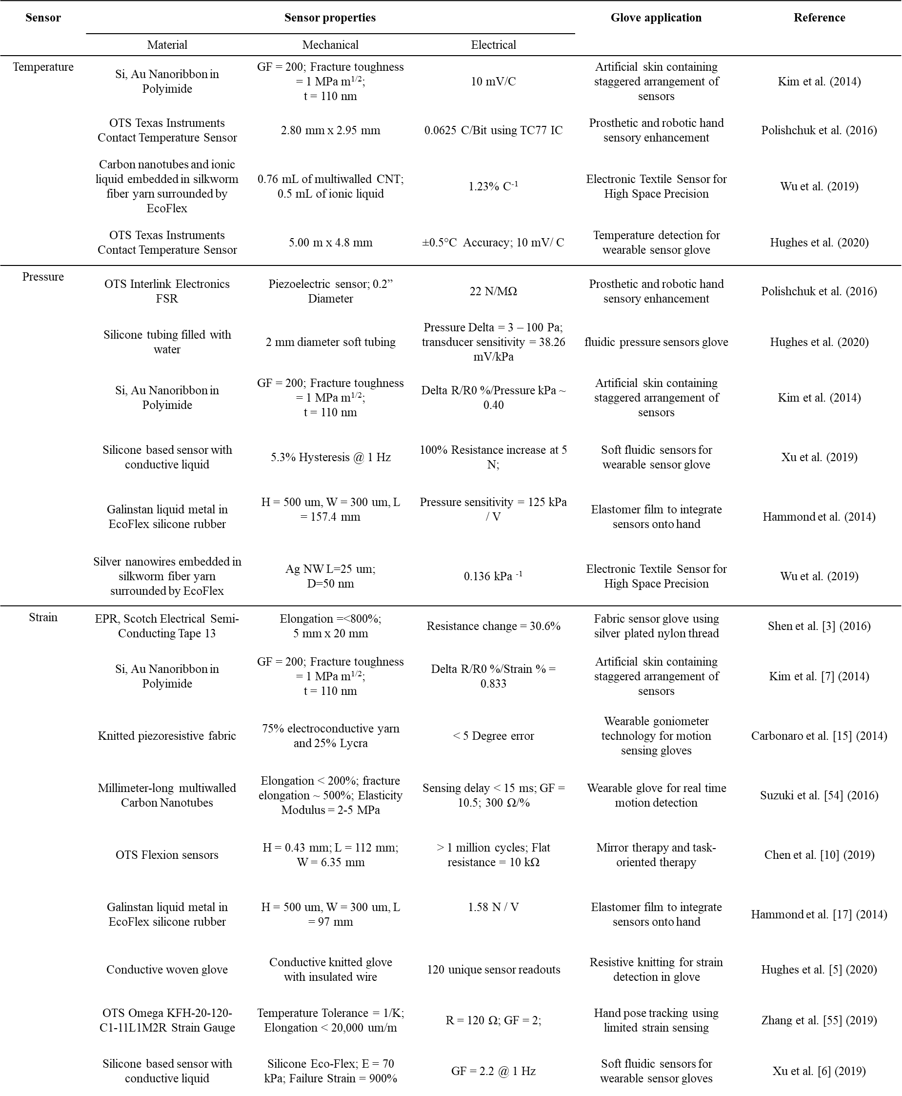

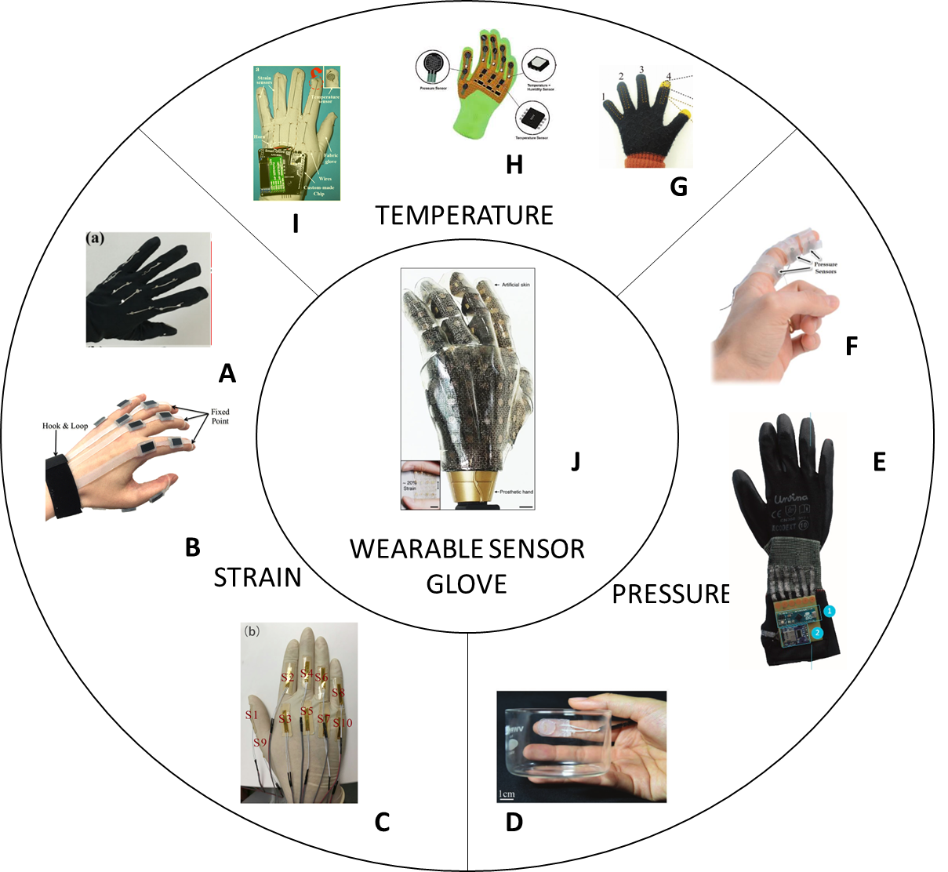

**Fig. 1. Wearable sensor gloves using different sensor technology.** (A) Glove with strain sensors made from a silver nanowire layer (Chen et al. 2016) (B) Glove with strain sensor made from ethylene propylene rubber (Shen et al. 2016) (C) Glove with strain sensors made from carbon particles embedded in nitrile butadiene rubber (Qu et al. 2020) (D) Glove with pressure sensors made from potassium iodide and glycerol solution (Xu et al. 2019) (E) Glove with pressure sensors made from Interlink 402 force sensitive resistors (Francés et al. 2019) (F) Glove with pressure sensors made from gallinstan conductive liquid (Hammond et al. 2014) (G) Glove with temperature sensors made from CNTs and [EMIM]Tf2N wrapped in conductive yarn encapsulated in Ecoflex (Wu et al. 2019) (H) Glove with temperature sensors made from off the shelf Ti TC77 ICs (Polishchuk et al. 2016) (I) Glove with temperature sensors made from MWNTs and PDMS (Li et al. 2020b) (J) Artificial skin with pressure, strain, and temperature sensors made from single crystalline silicon nanoribbon (Kim et al. 2014).

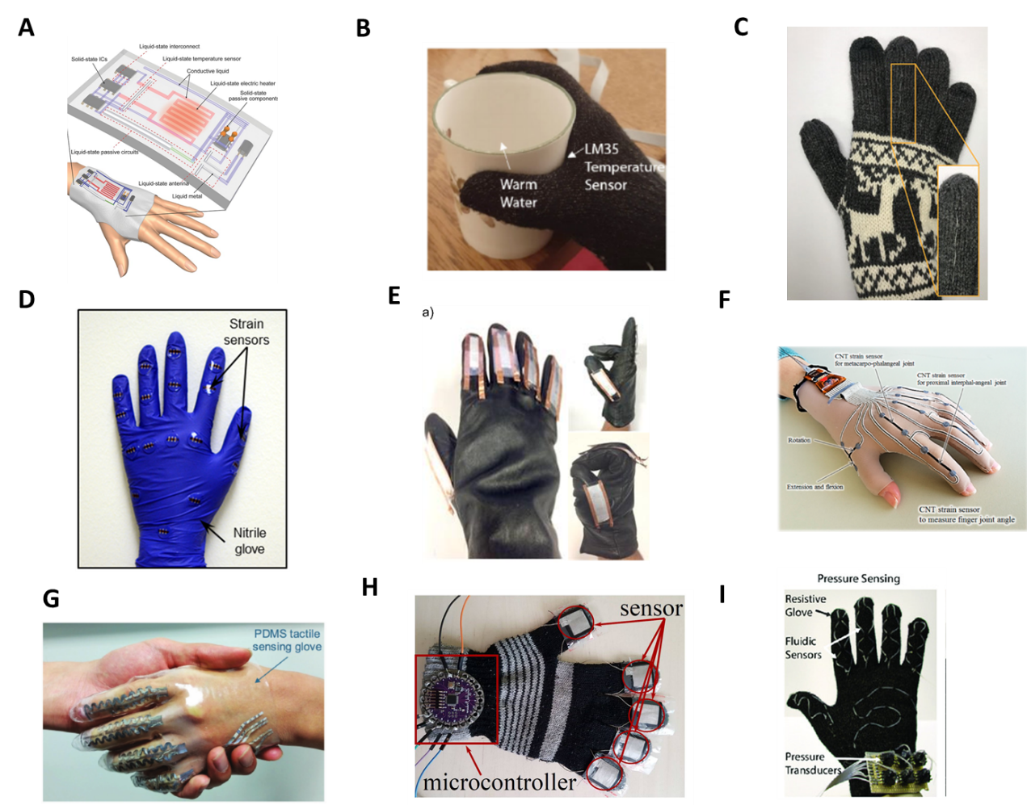

**Fig. 2. More examples of wearable sensor gloves using different sensor technology.** (A) Glove with temperature sensors made from liquid Galinstan material. (Ota et al. 2016) (B) Glove with temperature sensor made with Ti LM35 ICs (Hughes et al. 2020) (C) Glove with temperature sensors made from strain‐insensitive fiber with compressed micro‐wrinkles (Lee et al. 2020) (D) Glove with strain sensors made from poly nanofibrils percolated in silicone elastomer (Kim et al. 2018) (E) Glove with strain sensors made from vinylidene fluoride nanofibers (Khan et al. 2018) (F) Glove with strain sensors made from millimeter-long multiwalled CNTs (Suzuki et al. 2016) (G) Glove with pressure sensors made from embedded Galinstan microchannels (Gao et al. 2017) (H) Glove with pressure sensors made from anti-static sheets and conductive woven fabrics (Pizarro et al. 2018) (I) Glove with pressure sensors made from flexible fluidic tubes (Li et al. 2020b)

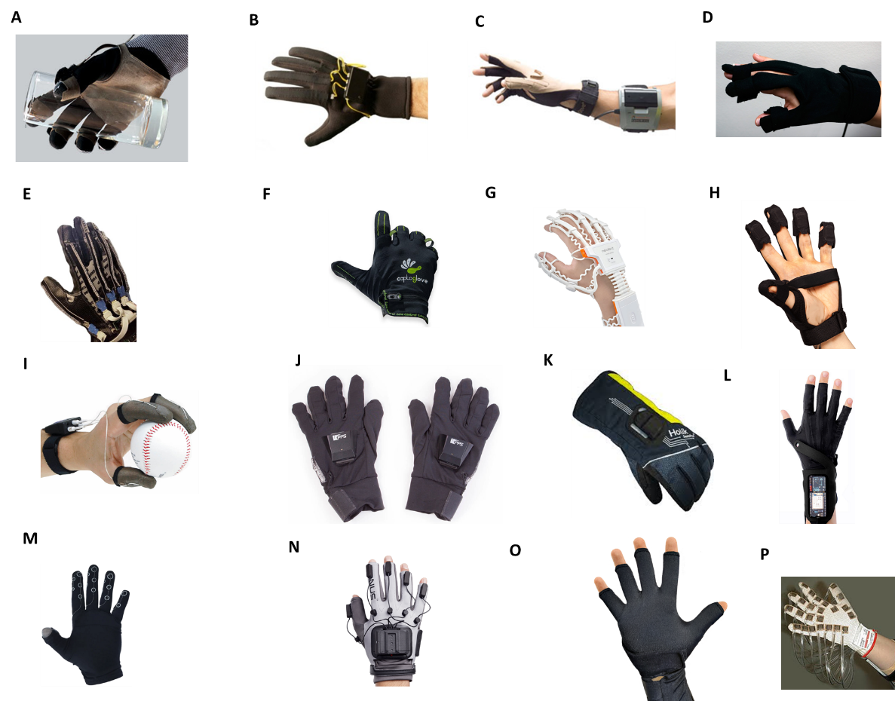

**Fig. 3. Commercial examples of wearable sensor gloves using different sensor technology.** (A) (Novel 2021) (B) (Virtual Realities 2018) (C) MoCap Pro SuperSplay gloves image courtesy of StretchSense (StretchSense 2021) (D) (Copyright Anthrotronix.com) (E) (Copyright FlexPoint.com) (F) (CaptoGlove 2020) (G) (Copyright NeofectUSA.com) (H) (BeBop 2021) (I) (PPS 2021a) (J) (PPS 2021b) (K) (Copyright Holik.cz) (L) (MimuGloves 2021) (M) (Peregrine 2021) (N) MANUS Prime II Haptic Glove (Manus-VR 2021) (O) (Copyright 5DT.com) (P) Courtesy of Vista Medical, Ltd. (Vista Medical)

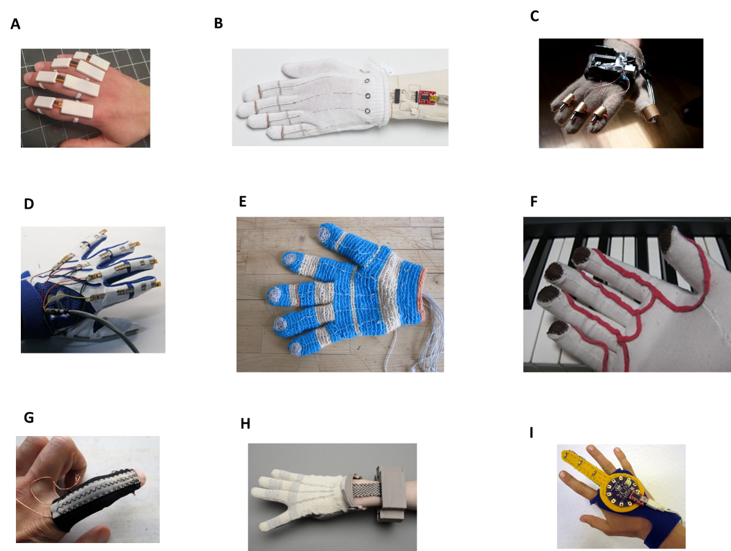

**Fig. 4. Do-It-Yourself prototypes of wearable sensor gloves using different sensor technology.** (A) (Freedman 2016) (B) (vu2aeo 2021) (C) (Shja7942 2021) (D) (Emcnany 2021) (E) (Freire 2021b) (F) (Plusea 2021) (G) (Donaldson 2021) (H) (Freire 2021a) (I) (DanielE58 2021)

**Table 2. Application and purpose of wearable sensor gloves.** This figure was derived and adapted from a previous literature review (Dipietro et al. 2008). This figure was updated to reflect the latest advancements in the past decade.

